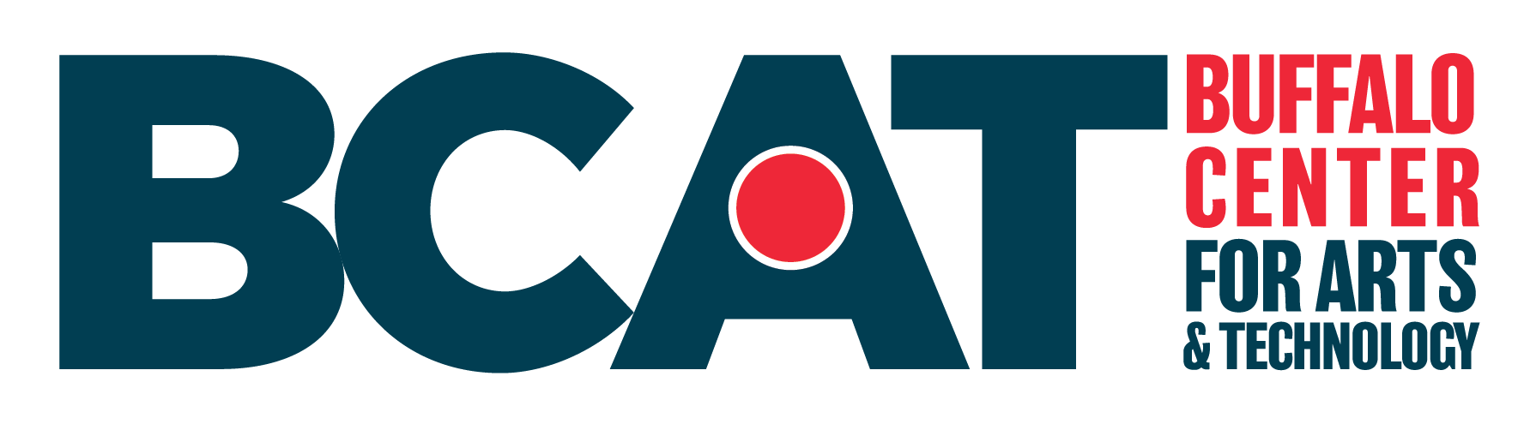
Buffalo Center for Arts and Technology (BCAT) is a not-for-profit that provide opportunities for careers through the arts, technology and workforce development. Our work improves high school graduation rates; provides safe environments to learn and prosper; develops family-sustainable wage earners; and contributes to economic/social growth in our community.
How to apply:
Interested candidates should submit a resume and cover letter and the names of three references to Cassie Puccia at cpuccia@bufcat.org. Please indicate which position you are applying for in the subject line. Applications will be accepted until the position is filled. BCAT is located at 1221 Main Street in Buffalo NY.
BCAT seeks an Adult Workforce Development Program Case Manager
Position Title: Adult Workforce Case Manager
Primary Reporting Responsibility: Adult Workforce Development Program Director
Status: In person, Full time or Part time

Job Description:
Buffalo Center for Arts and Technology (BCAT) is seeking an Adult Workforce Development Program Case Manager to work directly with adults in our Allied Health and Technology Programs. The responsibilities include supporting the adult students’ development and maintenance of positive personal agency, meeting their social and emotional needs, and building strategies that keep our students on a path to graduation and employment.
This position reports to the Adult Workforce Development Program Director. This position requires the case manager to schedule flexible hours Monday through Thursday between 10:30am and 7:30pm. BCAT classes are currently scheduled Monday through Thursday from 9am-8:30pm.

Essential responsibilities:
- Building a trusting, therapeutic relationship with adult participants
- Meeting individually at least twice per course with every adult participant
- Offering short-term non-clinical counseling to adults to meet mental health and other life challenges by strategizing solutions to address them
- Referring adults to an outside network of mental health providers, or other resources (e.g., food, transportation, childcare) when appropriate. Manage crises pertaining to mental health challenges
- Working closely with the adult workforce team/instructors to identify adults needing additional supports
- Collaborate with other BCAT staff to ensure adults achieve success in our program, and in employment after graduation.
The right candidate will have:
- Master’s degree in social work; LMSW preferred. Other counseling focused degrees will be considered.
- Minimum of two years’ experience working with adults in a case manager position
- Ability to form strong relationships with clients and stakeholders
- Excellent organizational, verbal, and written community skills
- Flexible, ability to work under pressure, and highly motivated to build successful outcomes for adult students
- Ability to pass a background check
Shared Values and Expectations:
- Serve as an ambassador of BCAT, demonstrating our mission and values positively and professionally and acting as a role model for our adult and youth students
- Show a solid commitment to Diversity, Equity, and Inclusion and contribute to BCAT’s community values which are to “respect, listen, embrace, shape, learn, influence.”
- Demonstrate professionalism and accountability at all times
- Contribute to the development and sustainability of BCAT
- Be willing to proactively help out where and when needed
- Exemplify a commitment to collaboration, teamwork and partnerships
- Take the initiative to analyze and solve problems
- Maintain a high standard of ethics, integrity, and confidentiality
About BCAT:
BCAT is an equal opportunity employer. All applicants will be considered for employment without attention to race, color, religion, sex, sexual orientation, gender identity, national origin, veteran, or disability status. BCAT seeks to recruit, develop and retain the most talented people from a diverse candidate pool.

