danceability
n. to empower through movement

DANCEABILITY, INC. is a nonprofit dance program for children and adults with special needs located in Cheektowaga, NY.

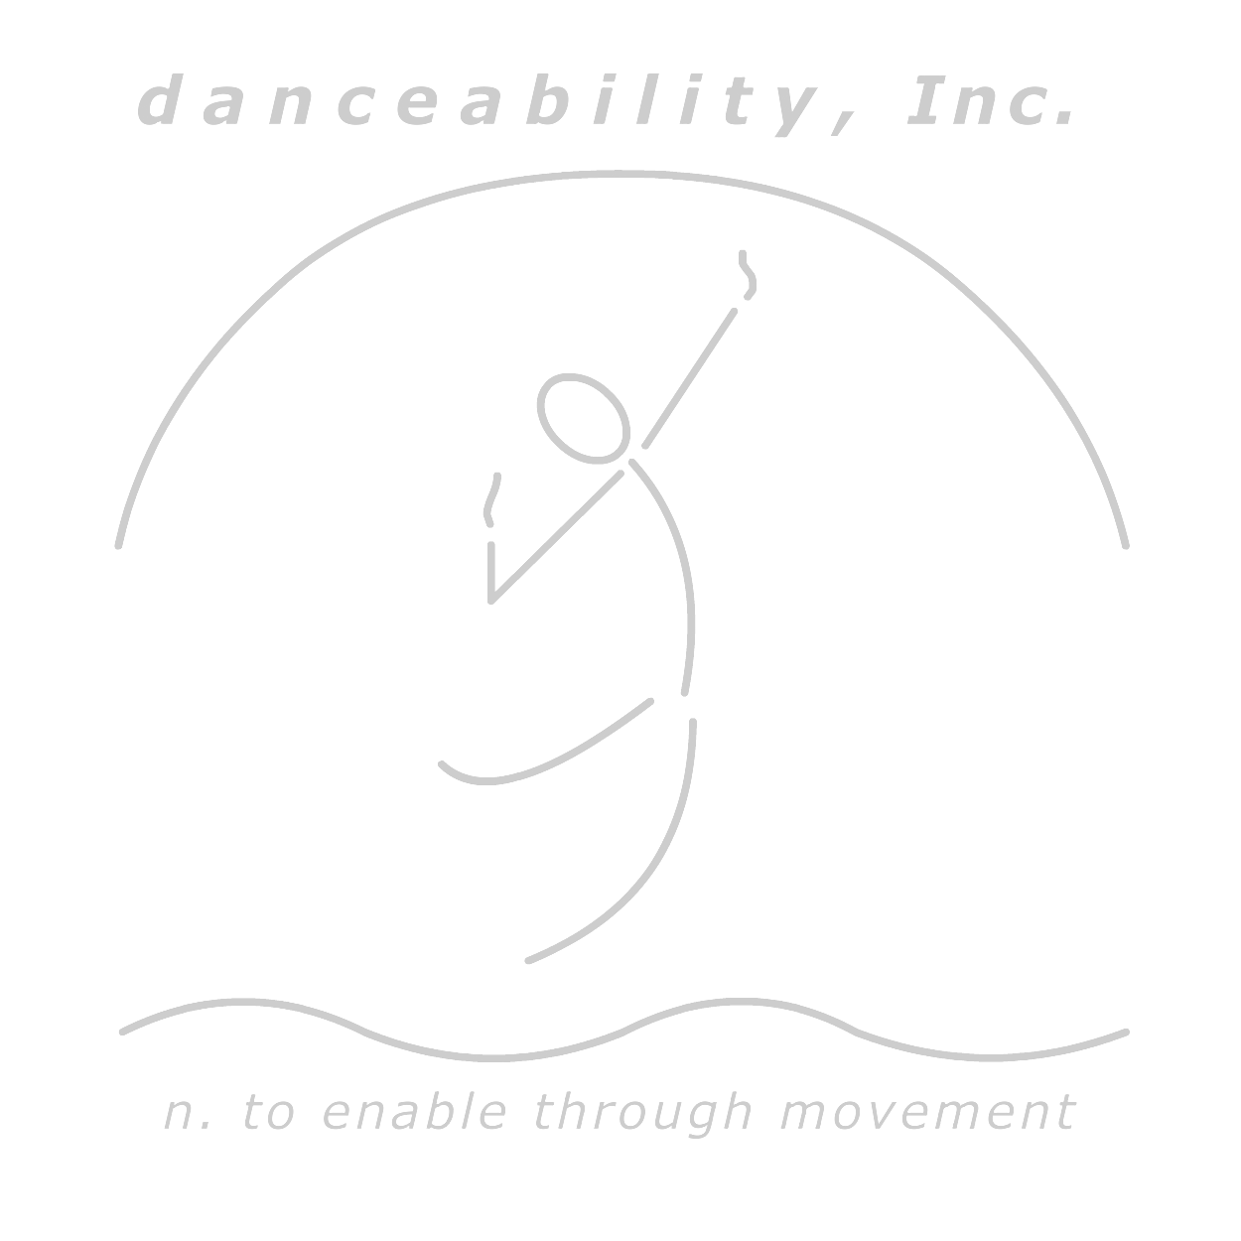
JOB TITLE:
Dance Instructor
SUMMARY:
The Dance Instructor is responsible for instructing and encouraging students, as well as demonstrating dance techniques and steps. Dance Instructor will prepare performance routines for the annual show.
Essential Duties and Responsibilities: (Other duties may be assigned as needed.)
- Teach approximately 1- 7 dance classes per week
- Prepare performance routines for annual show to include: choreography, costuming, music preparation
- Communicate with families and supervisors weekly regarding student progress and/or challenges
- Ability to move intermittently throughout the work day, inclusive of sitting, standing and bending, pushing, pulling, or moving objects or students
- Serve as a mentor to classroom volunteers
Professionalism:
- Demonstrate appropriate communication skills, both verbal and written
- Exhibit reasonably regular and predictable attendance and punctuality
- Demonstrate interest in, proficient understanding of, dedication to and support for the agency mission, values and philosophy
Qualifications:
- At least 10 years of dance education/training n in the last 12 years
- Collegiate Dance education is preferred
- Currently pursuing or possess a college degree in one or more of the following: dance, special education, physical therapy, occupational therapy, speech pathology, dance therapy or mental health field
- Experience working with children and/ or adults with special needs in a job / volunteer capacity; especially those with autism
- Availability to work evenings and/ or Saturdays
- Able to function with minimal supervision
- Availability to do summer training starting in July
- Applicant must prepare a 60 second dance piece in either, tap, jazz, modern or ballet for demonstration at interview
Interested individuals may apply by emailing their resume and cover letter to danceabilitywny@gmail.com
3859 Union Road, Cheektowaga, NY 14225 Ste 600
Phone: 651-0094 Email: danceabilitywny@gmail.com
Website: www.danceabilityinc.com

